**Project Design Phase-II**

**Technology Stack (Architecture & Stack)**

|  |  |
| --- | --- |
| Date | 27 June 2025 |
| Team ID | LTVIP2025TMID59821 |
| Project Name | Pattern Sense: Classifying Fabric Patterns Using Deep Learning |
| Maximum Marks | 4 Marks |

**Technical Architecture:**

The Deliverable shall include the architectural diagram as below and the information as per the table1 & table 2

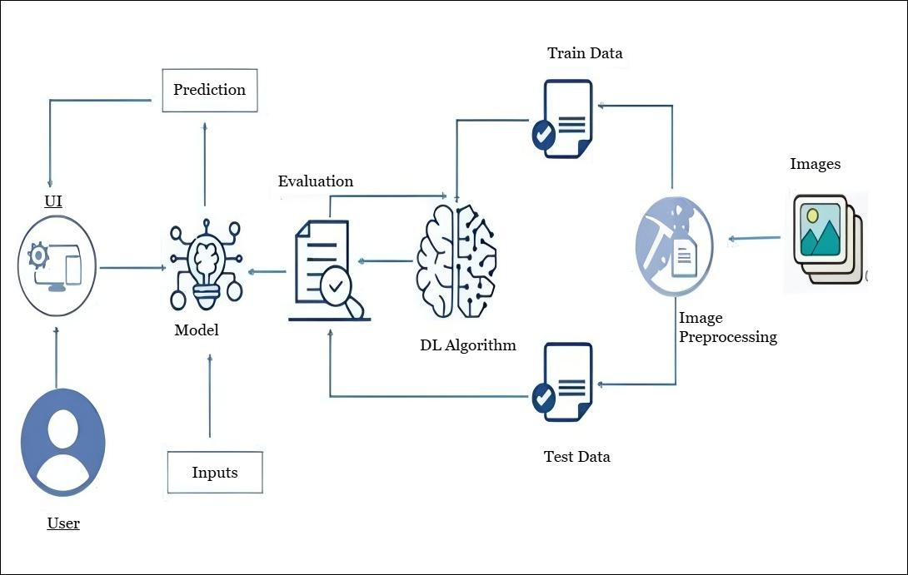

**Table-1: Components & Technologies:**

|  |  |  |  |
| --- | --- | --- | --- |
| **S.No** | **Component** | **Description** | **Technology** |
| 1. | User Interface | How user interacts with application (Web Page) | HTML, CSS, Bootstrap, Flask (Python) |
| 2. | Application Logic | Logic for a process in the application | Python |
| 3. | File Storage | File storage requirements | Stores predicted images in Local Filesystem |
| 4. | Machine Learning Model | Purpose of Machine Learning Model | ResNet |
| 5. | Data | Data used to train the model | Dataset from Kaggle |

**Table-2: Application Characteristics:**

|  |  |  |  |
| --- | --- | --- | --- |
| **S.No** | **Characteristics** | **Description** | **Technology** |
| 1. | User-Friendly Interface | Simple, intuitive web interface for image upload and result visualization. | HTML, CSS, Bootstrap, Flask (Python) |
| 2. | Real-Time Prediction | Immediate classification of produce as healthy or rotten. | Flask backend, TensorFlow model |
| 3. | Extendable Dataset  Suppor | N ew produce types can be added by updating the dataset and retraining. | ImageDataGenerator, Keras, TensorFlow |
| 4. | Efficient Processing | Optimized ResNet model ensures fast and reliable predictions. | Pre-trained ResNet, Numpy |